**Student’s Project**

**MOROCCO**

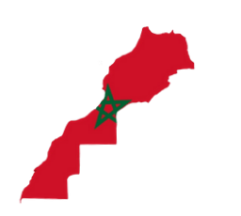

**A New Vision for Saving Water Sources in the Region of Fes Meknes**

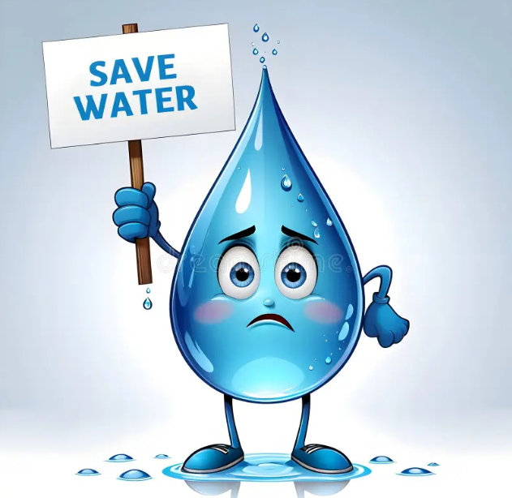

**The researcher : Rahmani Mohamed Karim**

Supervised by : Prof. Mohamed Fettah

School: Moulay Ismail High School

**Outline**

1. **Part One (Theory) ...........................................................**
2. **Introduction.**
   1. An overview of the project.
   2. Global perspectives on water resource management.
3. **Water availability and management challenges in the region of Fes Meknes.**
4. Current status of water resources.
5. Identification of issues threatening water sources.
6. Water-saving strategies.
7. **Proposed Solutions.**
8. Useful technological innovations.
9. Smart irrigation, water recycling, and purification methods.
10. Policy changes for sustainable water management.
11. Strategies for involving local communities in water conservation.
12. **Part Two (Practice) ........................................................**

* **Creating a poster about water crisis in the region of Fes Meknes.**
* **Making a video for sharing my own vision about practical steps for policymakers, local authorities, and communities.**

**Abstract**

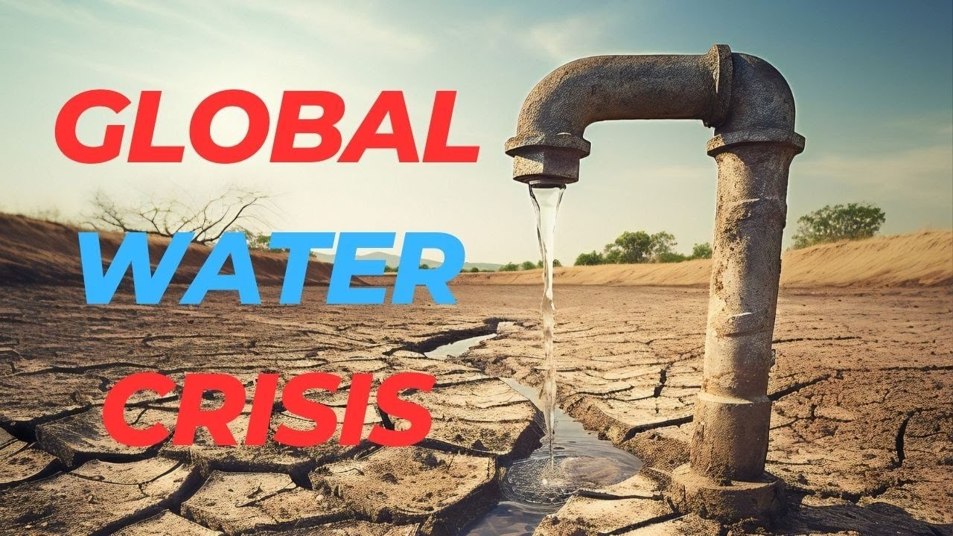

**The region of Fes-Meknes in Morocco faces significant water management challenges. Therefore, this research aims to identify the issues that threaten the water sources and then proposes certain strategies in order to overcome these challenges and save the water resources in this region.**

**The theoretical part of this research begins by providing a broad overview of global water resource management strategies and then focuses on the issues affecting Fes-Meknes. It also highlights the region's current water availability and management problems, such as overuse, pollution, and inefficient distribution systems. Apart from that, the research explores not only the role of policy changes in promoting sustainable water management practices but also providing effective strategies for involving local communities in water conservation efforts.**

**In the practical section, the research takes a more hands-on approach by creating a visual awareness campaign about the water crisis in Fes-Meknes. First, a poster will be designed to convey the urgent need for water conservation. In addition, a video will be produced to present a my personal vision of actionable steps that policymakers, local authorities, and communities can take to address the water crisis. The video aims to engage a broader audience and encourage collective action toward sustainable water practices in the region.**

**Ultimately, this research seeks to contribute to the development of a sustainable water management plan for the region of Fes-Meknes. By combining technological solutions with policy changes and community involvement, this research introduces a comprehensive approach to saving water resources in the region.**

"Water is the basis of life and the origin of all civilizations; without it, no development or prosperity can be achieved."

Ibn Khaldun